CSP 544 : System and Network Security
Varun Gunda
A20453991
Lab 1

2.1 Task 1: Manipulating Environment Variables

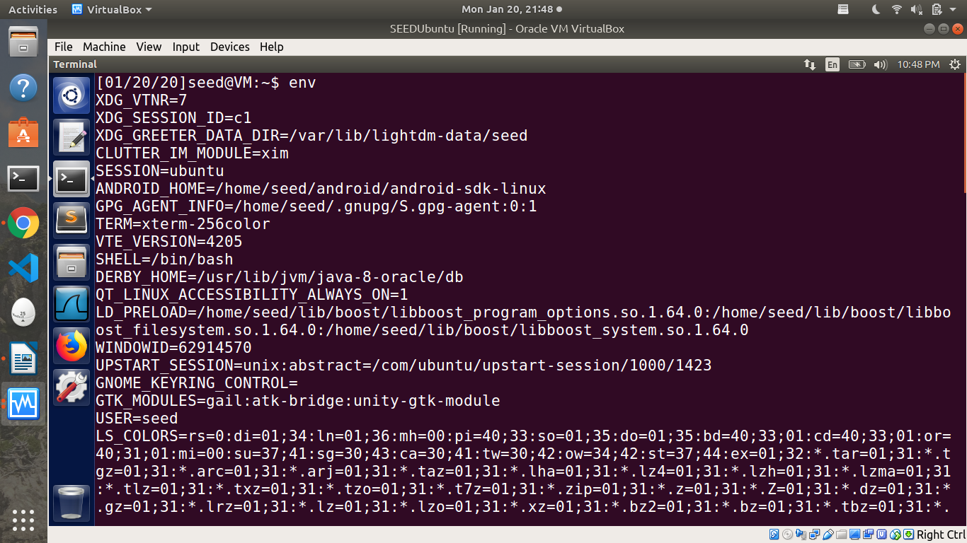
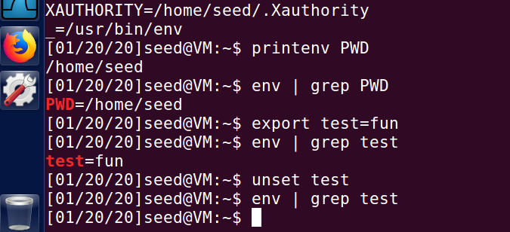

Env printenv prints all the environment variables. A variable “test” is created and is exported to make it environment variable. This is later unsetusing unset command.
2.2 Task 2: Passing Environment Variables from Parent Process to Child Process

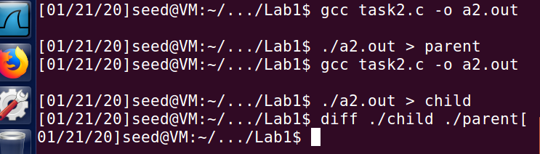
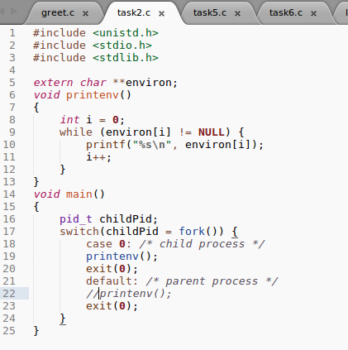

The child process gets all the environment variables of parent. This is because, the child process is created using a fork system call, and the child process’s memory is a duplicate of the parent’s memory.

2.3 Task 3: Environment Variables and execve()
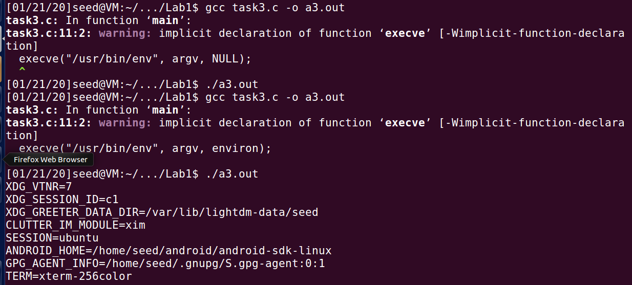
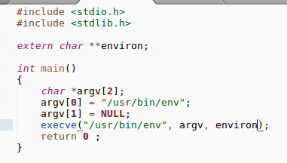
The third argument in the execve system call is the array that contains the environment for the new program. Initially when NULL is passed, the process did not pass any environment variable to the new process

2.4 Task 4: Environment Variables and system()
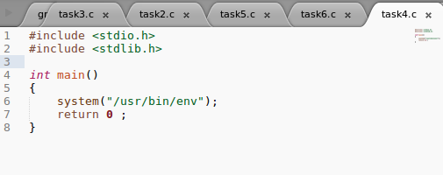
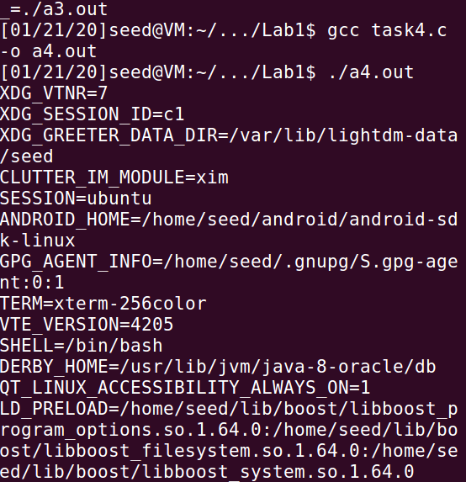
.
As seen above, the new program /bin/sh got all the environment variables through execve() called in system function.

2.5 Task 5: Environment Variable and Set-UID Programs
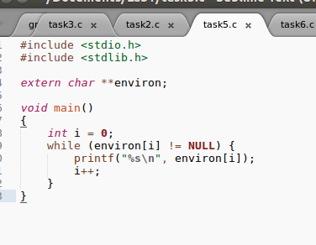

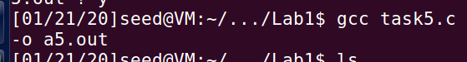
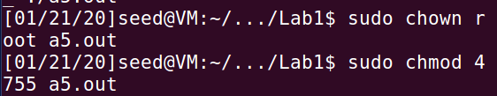
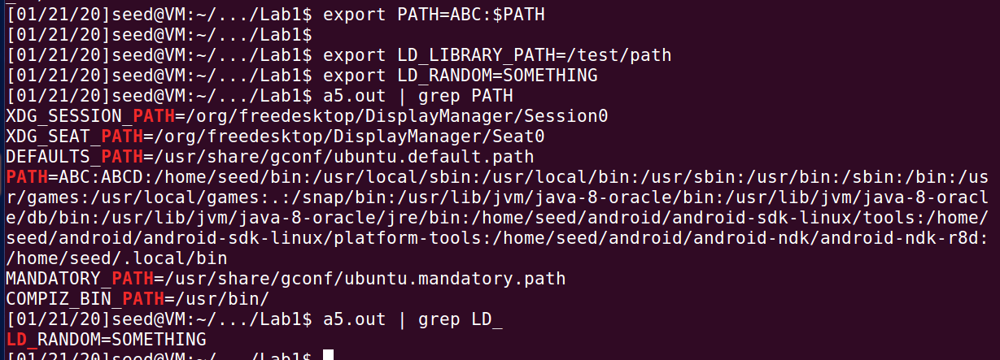
All the environment variables that were set in the shell process did not get into child process. The variable LD_LIBRARY_PATH is not present in the child process environment. This is because, the program that is running is a set-uid program, and there is a counter measure implemented by dynamic linker, which ignores LD_LIBRARY_PATH environment variable whrn the process’s real and effective user differ. The variable LD_RANDOM defined by me and not used by the dynamic linker and hence it is not a threat. However, LD_LIBRARY_PATH poses threat to set uid program since it is used by dynamic linker and therefore removed from the environment of the child process.

2.6 Task 6: The PATH Environment Variable and Set-UID Programs
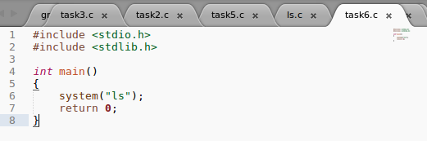

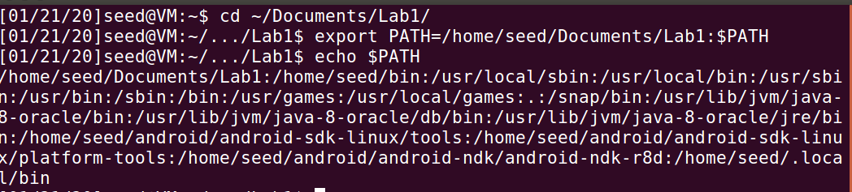
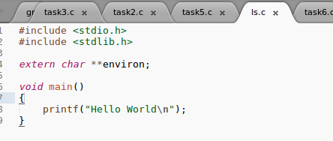

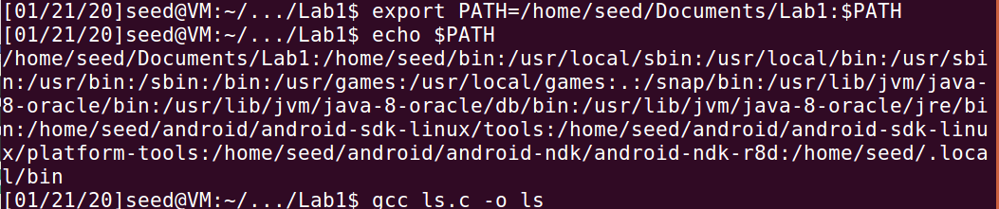

The program is running with root privilege and running the ls program written by me rather than “/bin/ls”. This is because PATH is set to look for /home/seed/Documents/Lab1 before any other directory for ls program. To confirm that the program is running with root privileges, I have performed following changes:

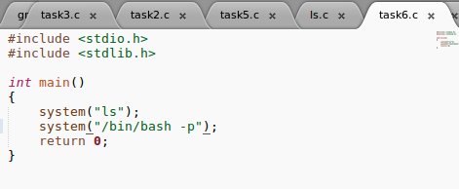

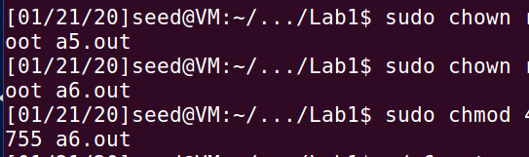

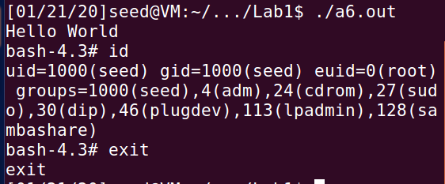

2.7 Task 7: The LD PRELOAD Environment Variable and Set-UID Programs

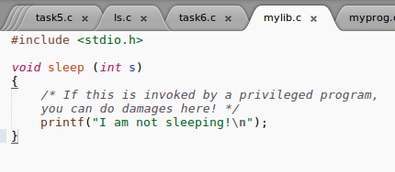

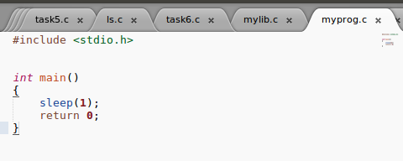

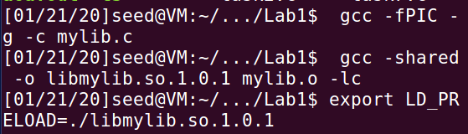

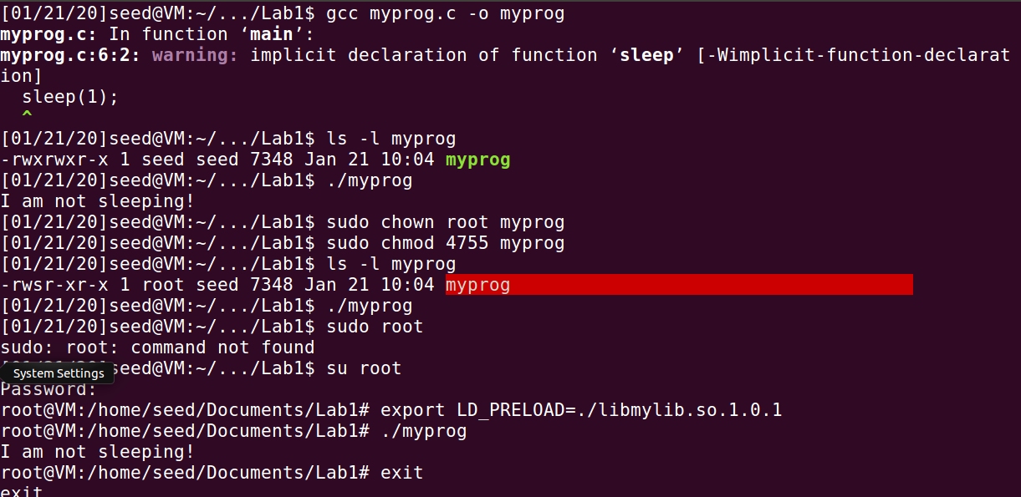

when myprog is a normal program, it is using the library created from mylib.c. The sleep() function is dynamically linked here. However when the myprog is changed to setuid program, the dynamic library is not using our sleep() method. This is because if our library can be linked to setuid programs, the attackers can use this method to get set-uid programs to run arbitrary code. Also, as seen in the Task 5, child processes will not inherit LD_* environment variables when it is a setuid program.

However, when the library is exported to root environment, since the setuid program runs in root environment (since the owner of the file is root), it gets this function from root’s environment and hence gets the sleep functions. The same applies when the program is owner by user1. Here we export the library to user1 environment and hence when setuid program runs, it gets sleep function from user1 environment

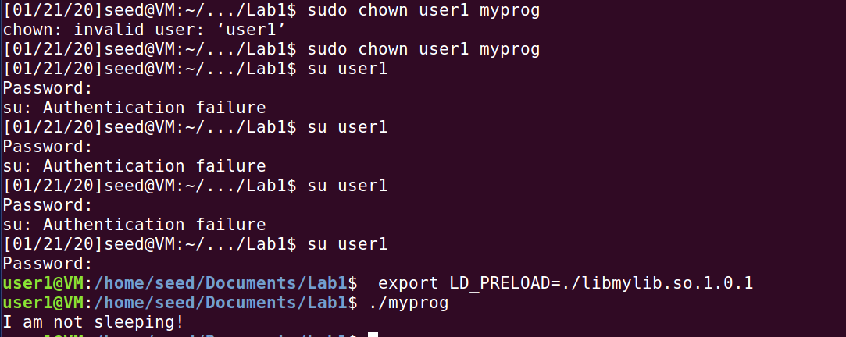

2.8 Task 8: Invoking External Programs Using system() versus execve()
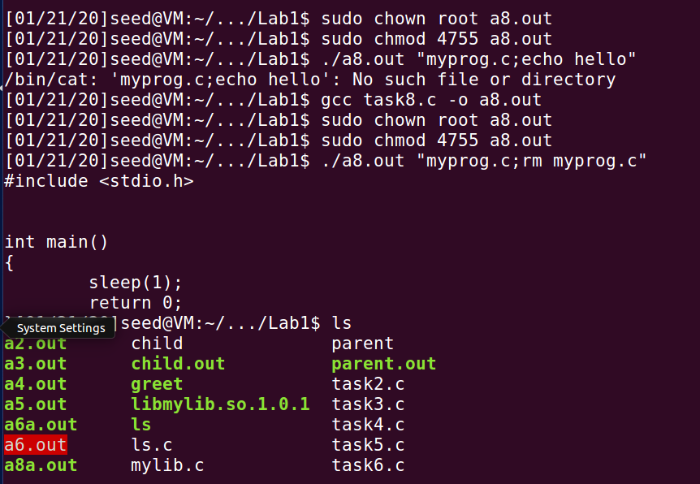

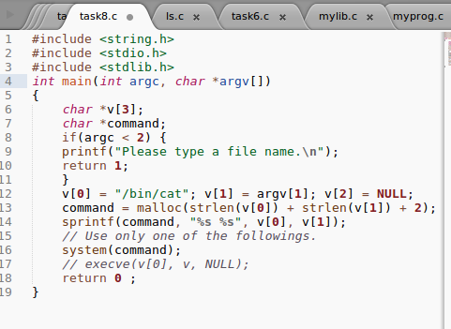

We can easily compromise the integrity of the system by using sequence operator as seen in the image above. Since system command opens a new shell, and this shell runs commands as a root runs them, we can delete the file as shown.

If execve is used instead of system, no new shell will be openedd but just the current program is changed by the new program. This is safer because it takes all the input as single argument and hence throws error as seen above.

2.9 Task 9: Capability Leaking

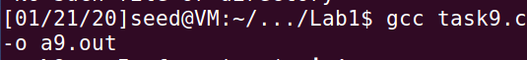

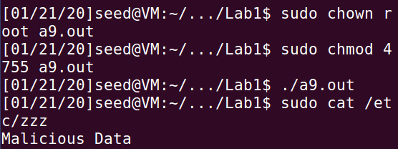
As seen, malicious data is being written to important file because “fd” still has root privileges in the child process. The child process is writing to the important file through this file descriptor.

